## Problem 1 – Watch Store

Create a Web page (HTML5 + CSS3 + images) that looks and behaves like the screenshots below:

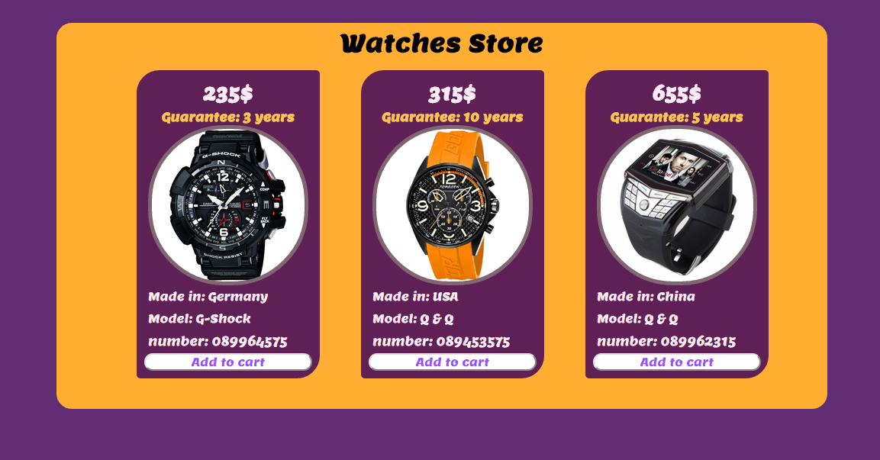

### Input

You are given the above screenshots + all required images + the texts on the site.

### Output

The output should be valid HTML5 + CSS3 + images that implement the above Web page.

### Constraints

* Font: Lemon-Regular / Arial
* Font size:
  + **24px** for the main title.
  + **22px** for price of watches.
  + **15px** for info of the watches.
  + **15px** for the buttons.
* Container width: 1000px.
* Watches container width: 900px.
* Columns width: 220px.
* Spacing between columns: 20px.
* The site should open correctly in Chrome 35.
* Responsive design is not required.
* Pixel-perfect implementation is not required.

## Problem 2 – Blog Page

Create a Web site (HTML5 + CSS3 + images) that looks and behaves like the screenshots below:

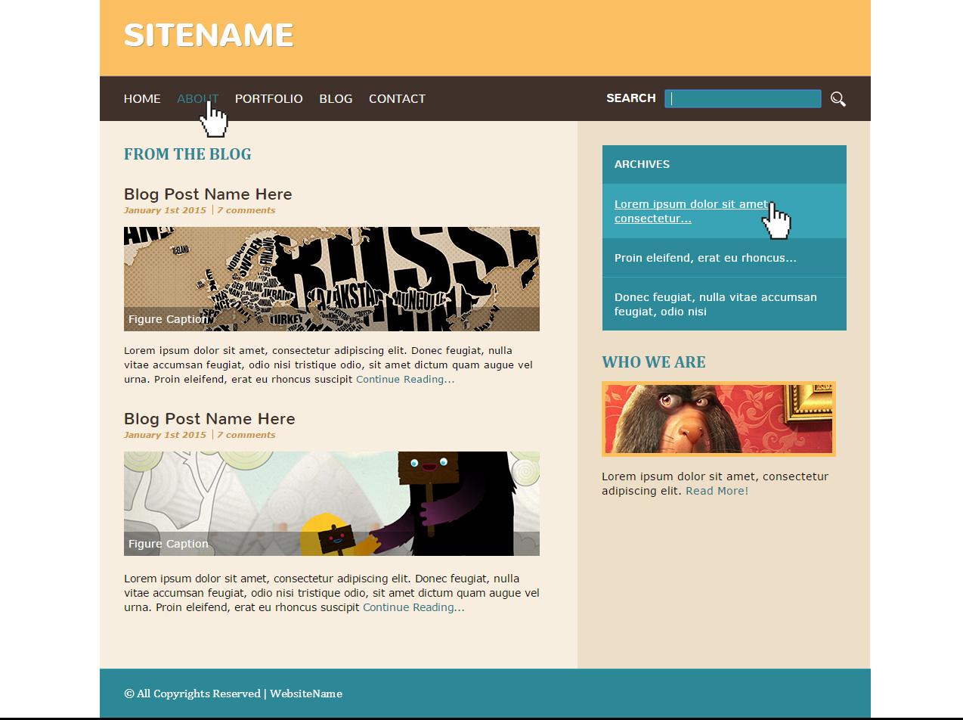

* The hand cursors in the screenshots show what happens when the mouse moves over certain elements.

### Input

You are given the above screenshots + all required images + the texts on the site.

### Output

The output should be valid HTML5 + CSS3 + images that implement the above Web site.

### Constraints

* Fonts:
  + Site title: Nunito, bold 700x42px, (<http://fonts.googleapis.com/css?family=Nunito>).
  + Header navigation: Nunito, 100x16px.
  + Title: Cambria, 22px.
  + Article Title: Nunito, 22px.
  + Article subtitle: Cambria, 10px.
  + Site content: Verdana, 13px.
  + Site footer: Cambria, 16px.
* Site content: fixed width 1020px.
* The site should open correctly in Chrome 35.
* Responsive design is not required.
* Pixel-perfect implementation is not required.

## Problem 3 – Login Form

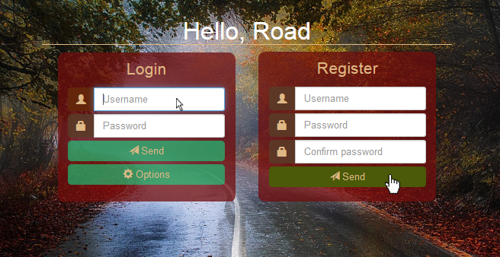Create a Web form (HTML5 + CSS3 + images) that looks and behaves like the screenshots below:

### Input

You are given the above screenshots + the background image.

### Output

The cursors in the screenshots demonstrate the form's behavior, do **NOT** implement them.

The output should be valid HTML5 + CSS3 + images that implement the above Web form.

### Constraints

* Main font: Tahoma, Helvetica, sans-serif.
* Main container for both forms must be 530 x 350px.
* Main container should be in the center of the Web page.
* The background image should cover the entire Web page.
* Form validation **is not required**.
* The site should open correctly in Chrome 35 and above.
* Responsive design **is not required**.
* Pixel-perfect implementation **is not required**.

**Problem 4 – Unresponsive to Responsive Site**

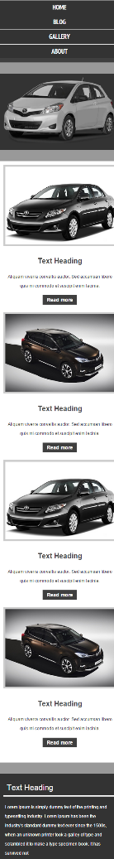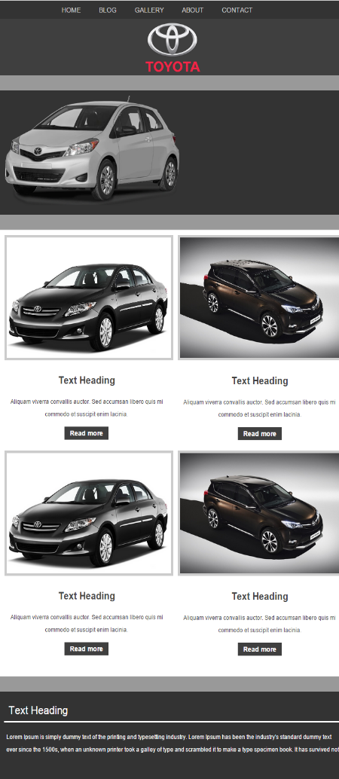You are given an unresponsive Web site (**HTML** + **CSS** + images). Your task is to **make the site responsive**. The site layout should change according to the browser viewport / screen size. You need to implement 2 layouts: **980px >** **width > 465px** , **width <= 465px**. The figures below represent these 3 layouts:

**Input**

You are given the unresponsive site as HTML + CSS + images.

**Output**

The output should be valid HTML5 + CSS3 + images that implement the above responsive site.

**Constraints**

* You are free to change the HTML and CSS, as well as use external frameworks like Bootstrap.
* Pixel-perfect implementation is **not required**.